# AN Tracker Mobile UI Requirements

# Preface:

This is the requirements document for AN Tracker Mobile UI. This document provide the guidance and suggestion for development of andriod mobile app. The mobile app will only store data locally (on phone memory) which is required for interaction with backend. The backend of this app is cloud based service which will be available through REST API.

**Please make sure to go through the UI Design Principal to understand the overall requirements.**

**The priority of the work in terms of UI develoment currently is to develop – all “create” related screens. The “view or list” screens may change.**

# UI Design Principal

* UI will be kept simple by showing only required field for creating various objects, if user want to add more details he can click on “Advanced” or similar link/button on the form.
* Frequently used data (e.g logged-in employee-id) will be stored in the mobile cache. The details given in the next section.
* Wherever date is applicable show the calendar menu and also populate the current date for data entry ease.
* All the UI labels/messages prompts should be internationalized, i.e. the UI should support multiple languages and for that, instead of actual label/message, a key will be used as a placeholders on the forms. The placeholders will be replaced with the language specific transalation.
* The mandatory field on the screen will be marked with *. This is not shown in the wireframes (mock screens given the document) .
* The field validation related errors/warning message should be shown inline with the field itself.
* The successful creation/failure (e.g Employee created successfully) message can be shown on the top of the form.
* Please make sure to use spell check during UI development for all menu/error/messages
* All list (i.e list customer, list invoice..) related pages should support pagination (10 items per page)
* Show fields which are not empty (e.g. if CGST,SGST,IGST, NetAmount is empty or 0 then do not show)
* Almost all search pages, the defualt date range would be 5 days to display records

# Following Items will be cached:

|  |  |
| --- | --- |
| **Important / Global Object** | **Description/Design** |
| LoggedInEmployeeID | * EmployeeID of the logged-in user |
| CreatedById | * Same as LoggedinEmployeeID * Store in the mobile app cache. * Hidden on Mobile UI * Need to pass to almost all API |
| OrgID | * Logged in user’s Organization Id * Store in the mobile app cache. * Hidden on Mobile UI * Need to pass to almost all API |
| City | * List of Cities * Store in the cache |
| Customer/Vendor | * Customer/Vendor accounts which are needed on many screens are cached in the mobile app. |
| ExpenseCategory | * List of Expense Category * It will be cached. |

# UI Forms

## Login

Requirements: User onces entered the credentials, the app should not ask the information. It should be logged in already like Amazon, Paytm etc untill it is logged out by the backend.

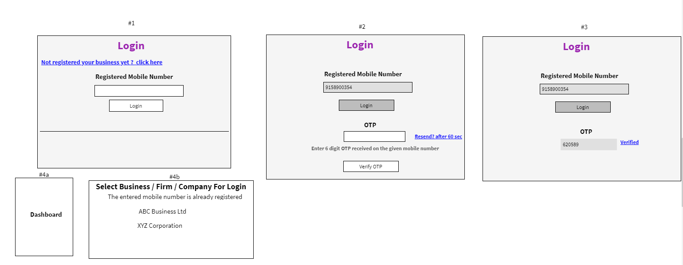

|  |  |  |
| --- | --- | --- |
| **Field** | **Validations** | **On Action** |
| Registered Mobile Number | Not Empty and 10 digit mobile number | Login |
|  |  |
|  |  |

|  |  |  |
| --- | --- | --- |
| **On Action** | **What to do** | **API to use** |
| Login |  |  |

Login with Mobile Number Only with OTP (Please note that other fields are grayed-out)

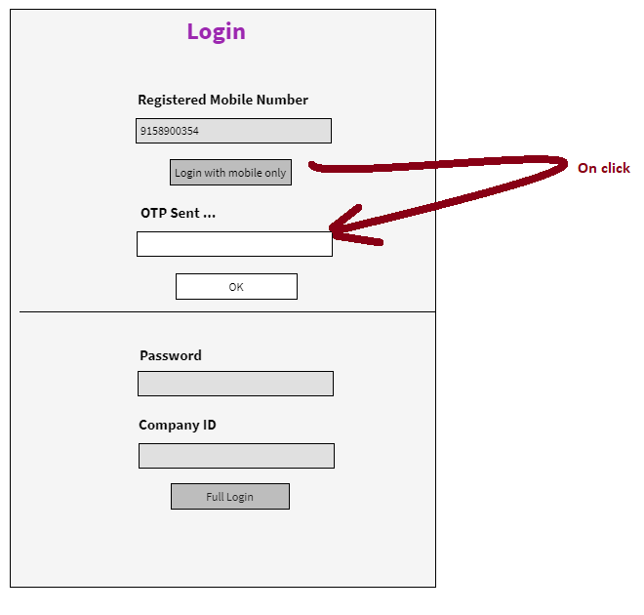

## Dashboard

Special Instuction:

1. All the dashboard items should be developed independently. Meaning in future, we can set visibility for each boxes. The box should be visible to the logged-in user or not.

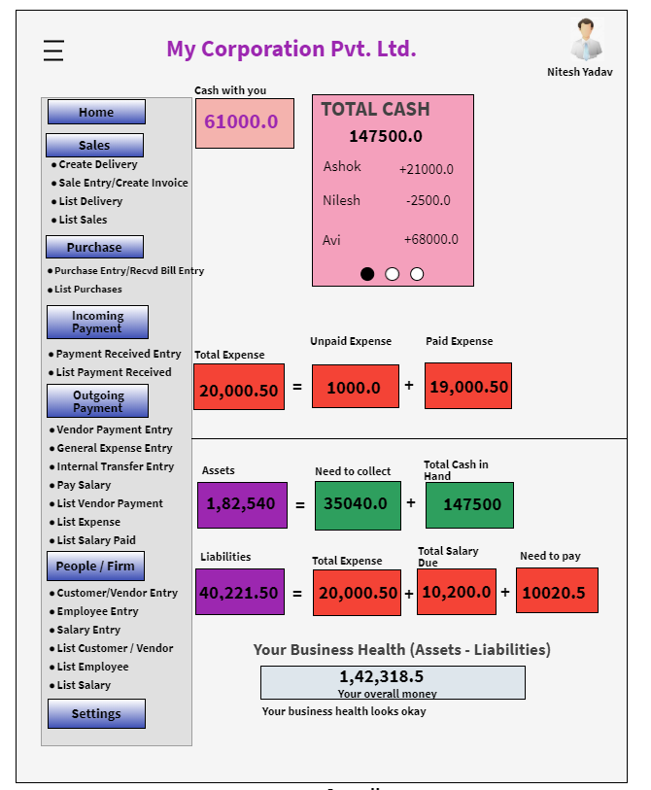

## Create Customer

We will show basic form. If end-user wants to see more fields then he/she can click on “Advanced”. Its basically one screen only but we are not showing all the fields by-default to not to scare the end-user.

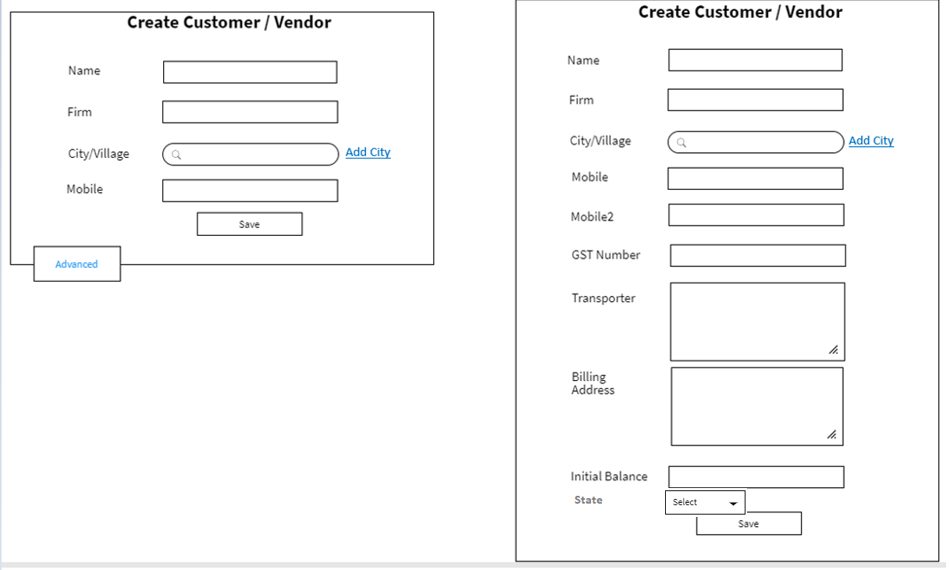

|  |  |  |
| --- | --- | --- |
| **Field** | **Validations** | **On Action** |
| Name* | Not Empty – atleast 2 characters | Save |
| City/Village * | Not Empty  Auto Type Search – after two characters |
| Mobile Number* | Not Empty – 10 digit number |
| GST Number | 15 character |
| Mobile2 | 10 digit number |
|  |  |

|  |  |  |
| --- | --- | --- |
| **On Action** | **What to do** | **API to use** |
| City/Village  Type 2 character – auto search | Search City/Village from the list |  |
| Save | Create Customer |  |
| Add City | Open popup to add city |  |

**Add City**

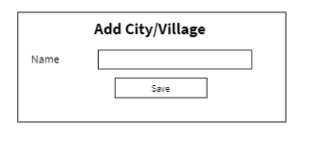

## List Customer/Vendor

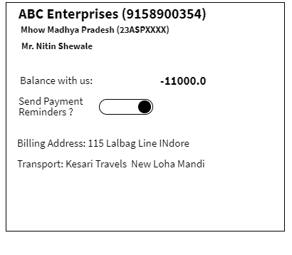

**Search Panel below:**

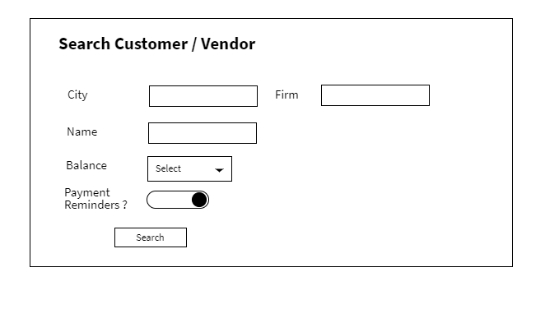

Balance: Positive / Negative

City/Firm/Name: Auto type search

**List Panel Explaination below:**

|  |  |
| --- | --- |
| ABC Entrprise (9158900354) | “Firm Name” (“Mobile Number”) |
| Mhow Madhya Pradesh | “City Name” “State” |
| Mr Nitin Shewale | “Name” only display when “firmname” and “name” different |

|  |  |  |
| --- | --- | --- |
| **On Action** | **What to do** | **API to use** |
| Auto Search (FirmName, Name, City) | Auto type the available things |  |
| Search | Do a customer/vendor search |  |
| Mobile Number Update | Do mobile number update |  |
| Send Payment Reminder? | On/Off |  |

## Delivery Create

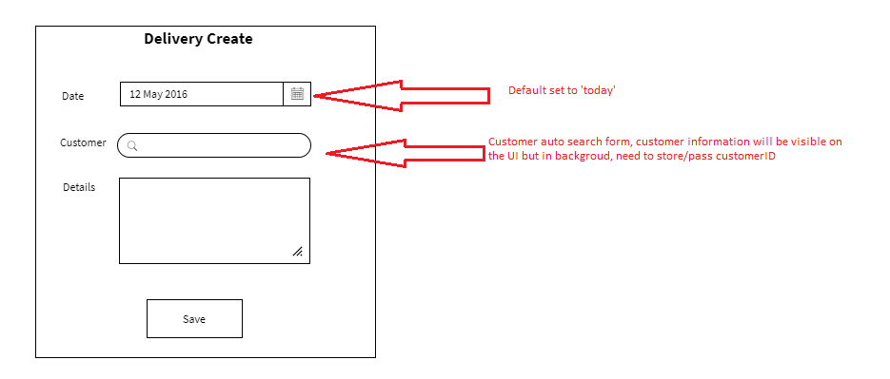

|  |  |  |
| --- | --- | --- |
| **Field** | **Validations** | **On Action** |
| Date* | Not Empty  default “today” | Save |
| Customer * | Not Empty |

|  |  |  |
| --- | --- | --- |
| **On Action** | **What to do** | **API to use** |
| Customer  Type 2 character – auto search | Search City/Village from the list |  |
| Save | Create Delivery |  |

## List Delivery

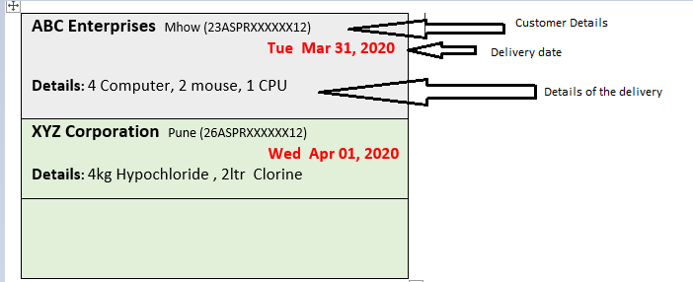

**Search Panel**

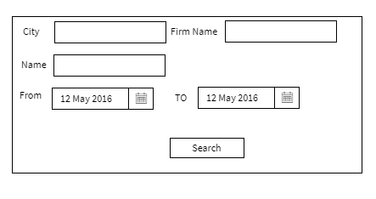

|  |  |  |
| --- | --- | --- |
| **On Action** | **What to do** | **API to use** |
| City, Firm Name, Name  Type 2 character – auto search |  |  |
| Default Search | Last 5 days (Set from and to Date accordingly) |  |

## Purchase Entry/Received-Bill Entry

The form will show basic form fields to create a bill, if a user wants to enter more details:- he can click on “Advanced”

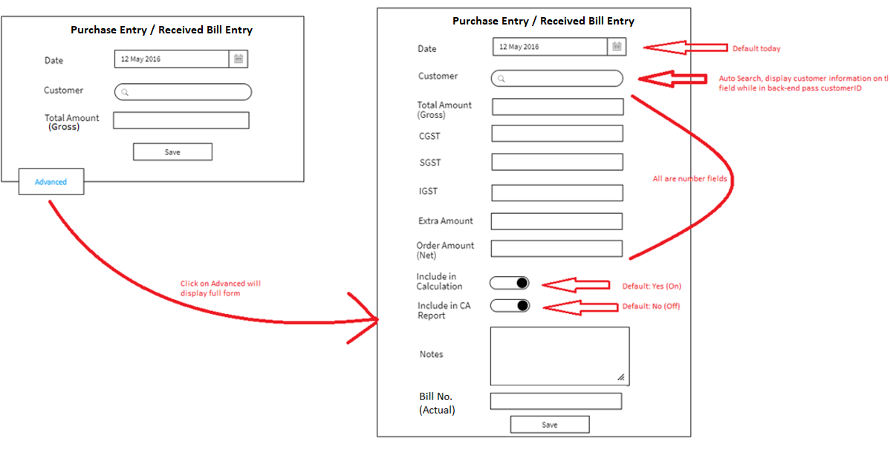

|  |  |  |
| --- | --- | --- |
| **Field** | **Validations** | **On Action** |
| Date* | 1. Not Empty 2. default “today” | Save |
| Customer * | Not Empty |
| Total Amount (Gross) | 1.Not Empty  2.Numbers only |  |
| CGST,SGST,IGST, Extra Amount, Order Amount(Net) | If value is present, it is number. |  |

|  |  |  |
| --- | --- | --- |
| **On Action** | **What to do** | **API to use** |
| Customer Search  Type 2 character – auto search | Search Customer’s **account** (not customer actually) |  |
| Save | Create Purchase Entry |  |

## List Purchases

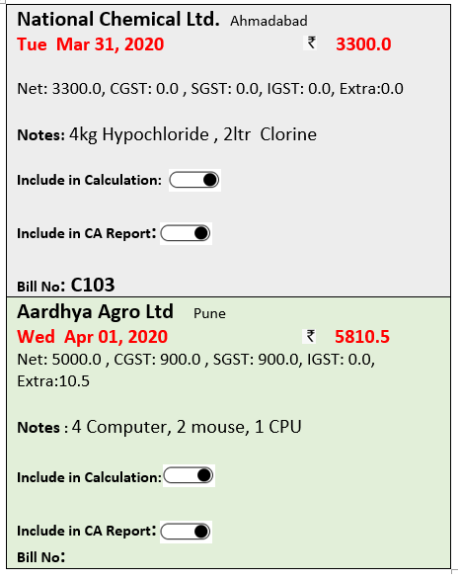

Search Panel

Same as Delivery

**Search Panel explaination below:**



## Create Expense

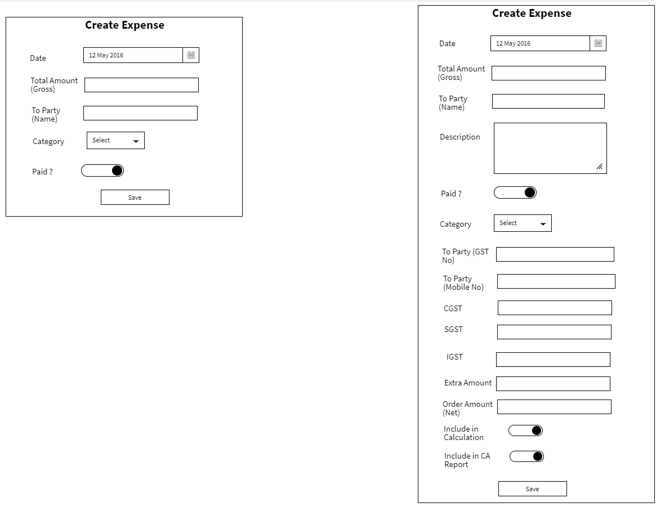

|  |  |  |
| --- | --- | --- |
| **Field** | **Validations** | **On Action** |
| Date | 1. Not Empty 2. default “today” | Save |
| Total Amount (Gross) | 1.Not Empty  2.Numbers only |  |
| To Party (Name) | Not Empty  Atleast 3 characters |  |
| Category | Not Empty |  |
| Include in calculation, Paid | Default “Yes/On” |  |
| Include in CA Report | Default “False” |  |

|  |  |  |
| --- | --- | --- |
| **On Action** | **What to do** | **API to use** |
| Category – List | Show Category list |  |
| Save | Create Sales Entry /Create Invoice |  |
| To Party :  Auto Search 2 Characters |  |  |

## List Expense

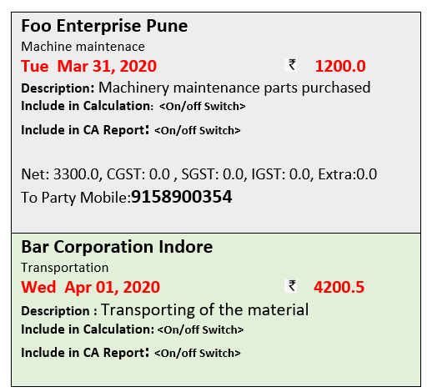

Field explanation

|  |  |
| --- | --- |
| Foo Enterprise Pune | To party Name |
| Machine Maintenance | Category |

|  |  |  |
| --- | --- | --- |
| **On Action** | **What to do** | **API to use** |
| Include in CA Report? | Change |  |
| Include in Calculation? | Change |  |

## Create Payment Received

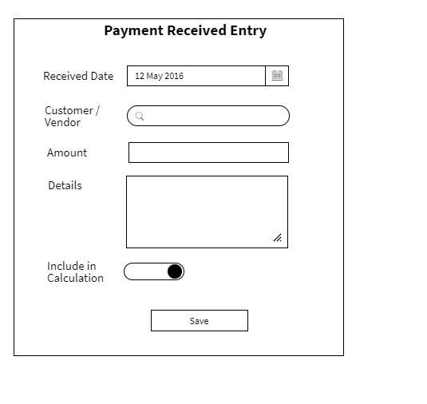

**Mandatory Fields**: Received Date, Customer/Vendor, Amount,

**Hidden Field:**

CreatedById = Logged in User ID

Received By: Account ID

**Populate UI fields:**

Customer/Vendor :

|  |  |  |
| --- | --- | --- |
| **Field** | **Validations** | **On Action** |
| Received Date* | 1. Not Empty 2. default “today” | Save |
| Customer/Vendor | Not Empty |
| Amount | 1.Not Empty  2.Numbers only |  |
|  |  |  |
| Include in calculation | Default “Yes/On” |  |
|  |  |  |

|  |  |  |
| --- | --- | --- |
| **On Action** | **What to do** | **API to use** |
| Customer/Vendor – Search | User Type 2 characters and auto-search starts and shows the list of customer’s accounts  Search on Account instead of Customer/Vendor |  |
| Save | Create a Payment Received |  |

## List Payment Received

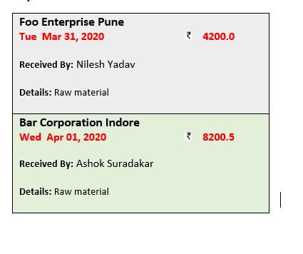

## Sales Entry / Create Invoice

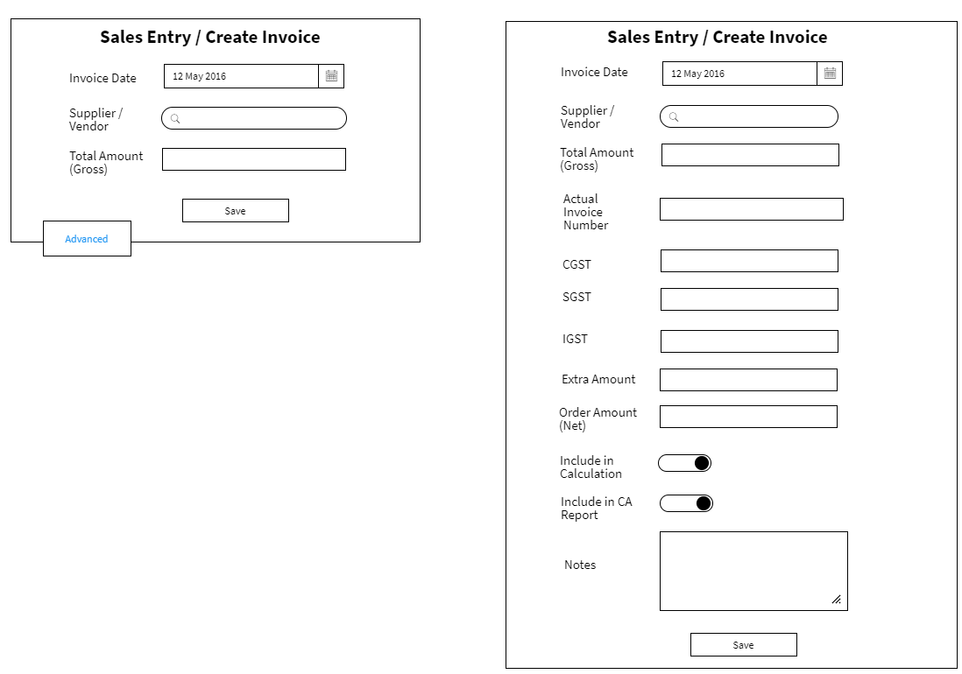

|  |  |  |
| --- | --- | --- |
| **Field** | **Validations** | **On Action** |
| Invoice Date* | 1. Not Empty 2. default “today” | Save |
| Supplier/Vendor * | Not Empty |
| Total Amount (Gross) | 1.Not Empty  2.Numbers only |  |
| CGST,SGST,IGST, Extra Amount, Order Amount(Net) | If value is present, it is number. |  |

|  |  |  |
| --- | --- | --- |
| **On Action** | **What to do** | **API to use** |
| Supplier/Vendor Search  Type 2 character – auto search | Search Customer’s **account** (not customer actually) |  |
| Save | Create Sales Entry /Create Invoice |  |

## List Sales

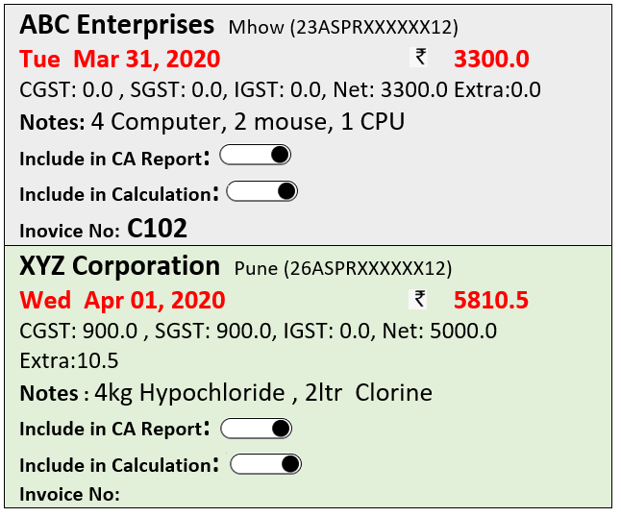

## Pay To Vendor

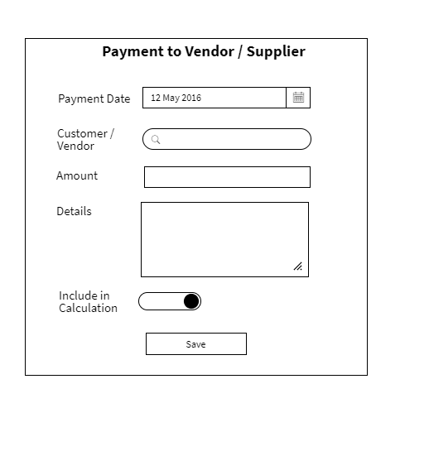

|  |  |  |
| --- | --- | --- |
| **Field** | **Validations** | **On Action** |
| Payment Date* | 1. Not Empty 2. default “today” | Save |
| Customer/Vendor | Not Empty |
| Amount | 1.Not Empty  2.Numbers only |  |
|  |  |  |
| Include in calculation | Default “Yes/On” |  |
|  |  |  |

|  |  |  |
| --- | --- | --- |
| **On Action** | **What to do** | **API to use** |
| Customer/Vendor – Search | User Type 2 characters and auto-search starts and shows the list of customer’s accounts  Search on Account instead of Customer/Vendor |  |
| Save | Create PayToVendor |  |
|  |  |  |

## List Pay To Vendor

|  |
| --- |
| **National Chemical Ltd.** Ahmadabad  **Tue Mar 31, 2020 3300.0**  **Done By:** Nilesh Yadav  **Details:** Raw material |
| **Aardhya Agro Ltd** Pune  **Wed Apr 01, 2020 5810.5**  **Done By:** Ashok Suradakar  **Details:** Raw material |

## Internal Transfer

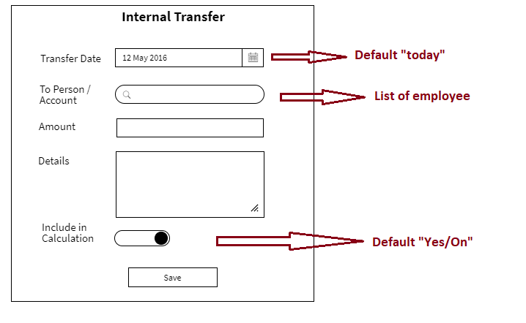

|  |  |  |
| --- | --- | --- |
| **Field** | **Validations** | **On Action** |
| Transfer Date* | 1. Not Empty 2. default “today” | Save |
| To Person/Account | Not Empty |
| Amount | 1.Not Empty  2.Numbers only |  |
|  |  |  |
| Include in calculation | Default “Yes/On” |  |
|  |  |  |

|  |  |  |
| --- | --- | --- |
| **On Action** | **What to do** | **API to use** |
| To Person/Account – Search | User Type 2 characters and auto-search starts and shows the list of employee’s accounts  Search on Account |  |
| Save | Create InternalTransfer |  |
|  |  |  |

## List Internal Transfer

|  |
| --- |
| **Tue Mar 31, 2020 4200.0**  **From:** Nilesh Yadav  **To:** Nilesh Yadav  **Details:** Galla |
| **Wed Apr 01, 2020 8200.5**  **From:** Ashok Suradakar  **To:** Avinash Yadav  **Details:** Galla |

## Create Employee

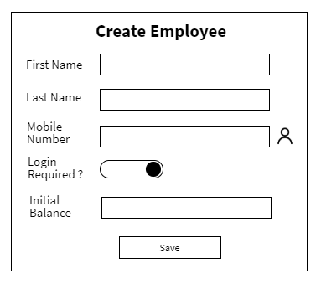

|  |  |  |
| --- | --- | --- |
| **Field** | **Validations** | **On Action** |
| First Name* | Not Empty – atleast 2 characters | Save |
| Mobile Number* | Not Empty – 10 digit number |
| Initial Balance | Number |

|  |  |  |
| --- | --- | --- |
| **On Action** | **What to do** | **API to use** |
| Save | Create Employee |  |
| Address Book | Open the contacts of the user to select the mobile number | - |

## List Employee

Please note : The Company Balance field, Login Enabled Button, Attendance:Entry, Attendance:Exit are rendered based on the some condition. These are not visible to all user by default.

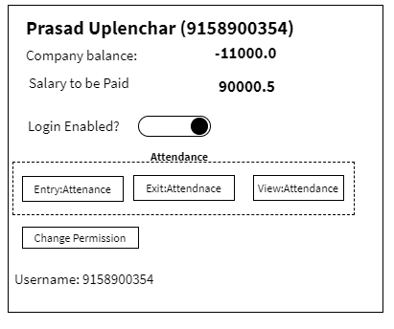

Editable Fields: Mobile Number, Login Enabled?

Name cannot be changed.

**Search Employee Screen**

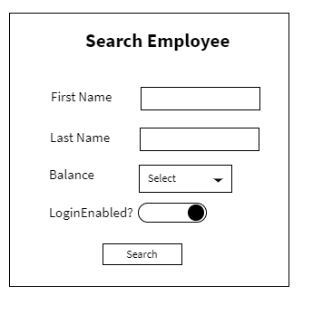

## Create Salary

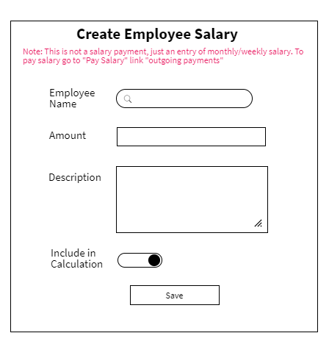

|  |  |  |
| --- | --- | --- |
| **Field** | **Validations** | **On Action** |
| Employee Name* | 1. Not Empty | Save |
| Amount | 1.Not Empty  2.Numbers only |  |
| Description | 1.Not Empty |  |
| Include in calculation | Default “Yes/On” |  |

|  |  |  |
| --- | --- | --- |
| **On Action** | **What to do** | **API to use** |
| Employee Name – Search | User Type 2 characters and auto-search starts and shows the list of employee |  |
| Save | Create an Employee |  |

## Salary Transfer

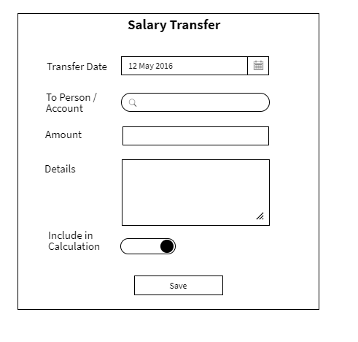

|  |  |  |
| --- | --- | --- |
| **Field** | **Validations** | **On Action** |
| Transfer Date* | 1. Not Empty 2. default “today” | Save |
| To Person / Account* | Not Empty |  |
| Amount* | 1.Not Empty  2.Numbers only |  |
| Include in calculation* | Default “Yes/On” |  |

|  |  |  |
| --- | --- | --- |
| **On Action** | **What to do** | **API to use** |
| To Person / Account – Search | User Type 2 characters and auto-search starts and shows the list of employee |  |
| Save | Create a Salary Transfer |  |

## List Salary

|  |
| --- |
| **Prasad Uplenchar (9893012547)**    **Date: Tue April 3, 2020**  **Salary: 15000.0**  **Description:** For Month of March 2020  **IncludeInCalculation:** Yes |
| **Nitesh Yadav (9158900658)**  **Date: Tue April 2, 2020**  **Salary: 15000.0**  **Description:** For Month of March 2020  **IncludeInCalculation:** Yes |

## List Salary Paid

|  |
| --- |
| **Prasad Uplenchar (9893012547)**    **Paid Date: Tue April 3, 2020**  **Amount: 15000.0**  **Paid By:** Nilesh Yadav  **Description:** For Month of March 2020  **IncludeInCalculation:** Yes |
| **Nitesh Yadav (9158900658)**  **Paid Date: Tue April 2, 2020**  **Paid Amount: 15000.0**  **Paid By:** Nilesh Yadav  **Description:** For Month of March 2020  **IncludeInCalculation:** Yes |

## Business Registration

Note: Gray-out (make it non-editable/view-only) when on the next screen.

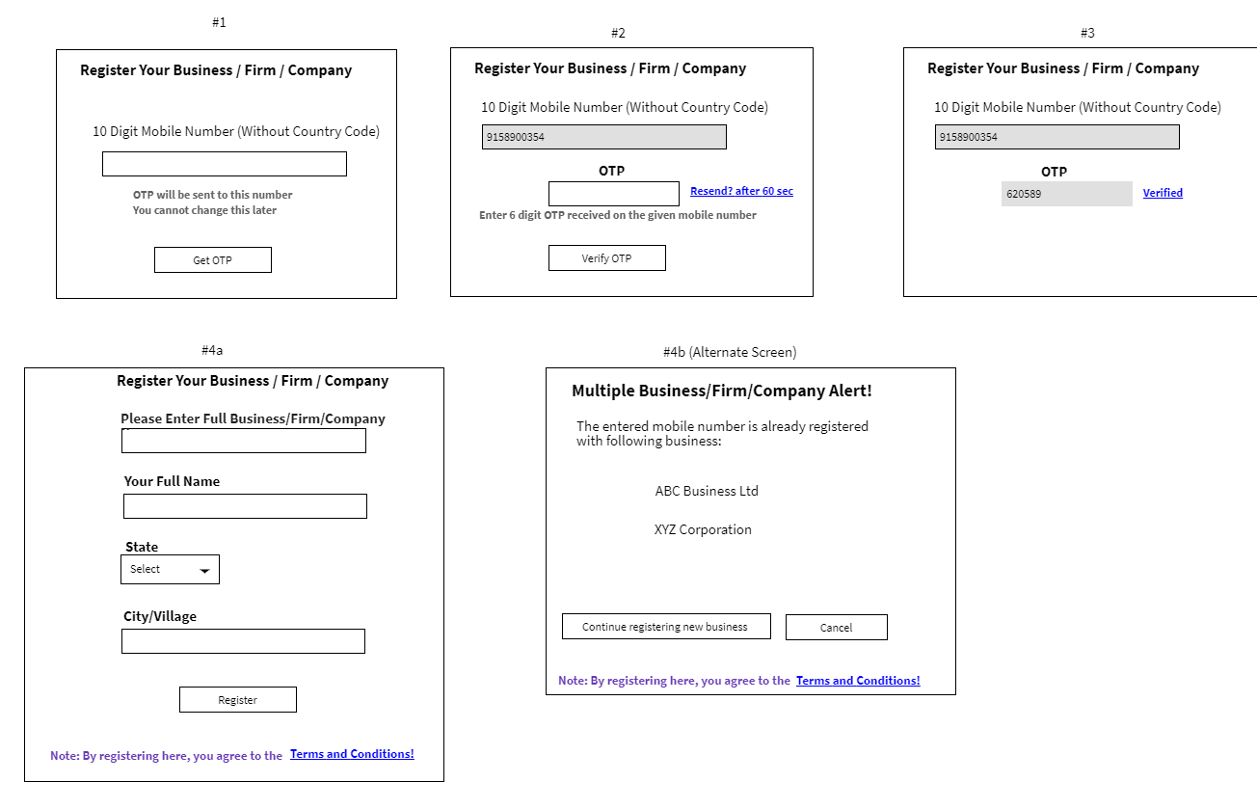

|  |  |  |
| --- | --- | --- |
| **Field** | **Validations** | **On Action** |
| Business Name | 1. Not Empty 2. Three characters | Save |
| Mobile Number | * Not Empty * 10 digit number |  |
|  | 1.Not Empty  2.Numbers only |  |
|  | Default “Yes/On” |  |

|  |  |  |
| --- | --- | --- |
| **On Action** | **What to do** | **API to use** |
| To Person / Account – Search | User Type 2 characters and auto-search starts and shows the list of employee |  |
| Save | Create a Salary Transfer |  |

## Attendance:Entry/Exit and Fingerprint Add

Please note that in two ways attenance can be recorded 1. Biomatric 2. Manual

Both option will send the location as part that.

**ENTRY**

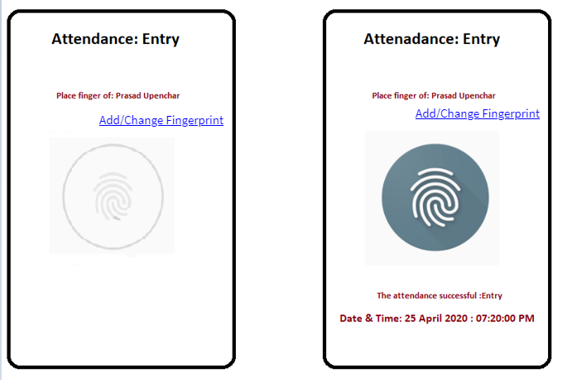

**EXIT**

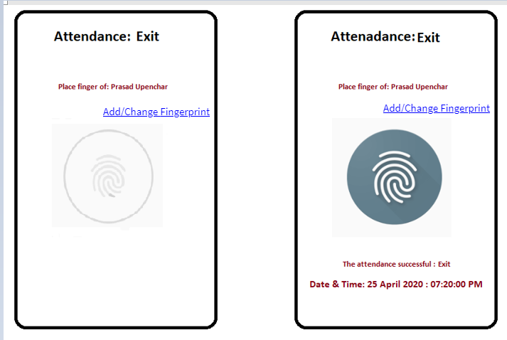

**Fallback Attendance**

In case FingerPrint Authentication Failure multiple times (configurable limit e.g 3), show alternate option of location based only attendance. In case of no-scanner device mobile, this settings can be organization wide.

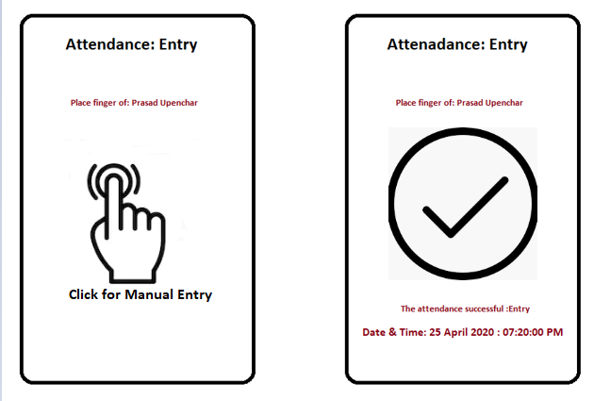

**Add Fingerprint**

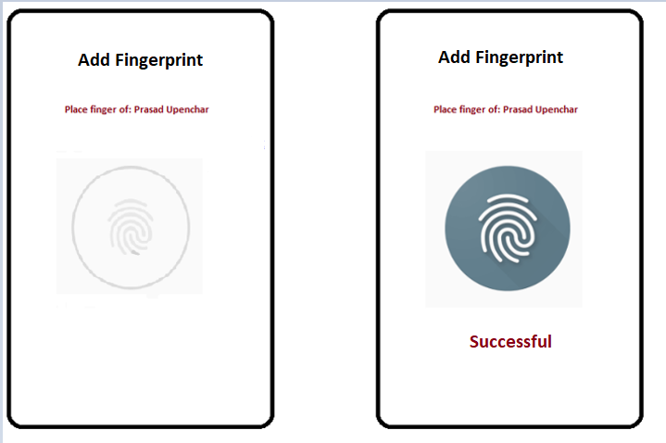

## View Attendandance

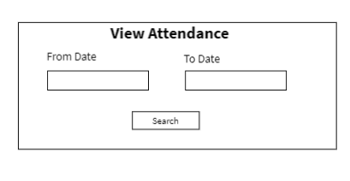

**Employee: Prasad Upenchar**

Total Hours Worked: **11 Hours**

|  |  |  |  |
| --- | --- | --- | --- |
| **Entry Time** | **Exit Time** | **Hours Worked** | **Other Details** |
| 25/04/2020 1:32PM  (Auto) | 25/04/2020 3:32PM  (Auto) | 2 | **Scanned By :** Navin Yadav  **Location:** Rajendra Nagar Indore |
| 26/04/2020 12:32PM  (Auto) | 26/04/2020 4:32PM  (Auto) | 4 | **Scanned By :** Navin Yadav  **Location:** Rajendra Nagar Indore |
| 27/04/2020 12:01AM  (Auto) | 27/04/2020 5:02AM  (Manual) | 5 | **Scanned By :** Navin Yadav  **Location:** Rajendra Nagar Indore |
|  |  |  |  |

# Task to Work On

|  |  |
| --- | --- |
| Task | Comments |
| Login using existing device fingerprint. |  |
| Work Hours tracking module |  |
| Edit of some of the items |  |
| Unpaid to Paid Expense |  |
|  |  |

# Appendix

List Salary Paid

<https://wireframepro.mockflow.com/editor.jsp?editor=on&bgcolor=white&perm=Create&ptitle=Test&category=form&projectid=M2842c70ddeae32ebe7ec3bebea90bc331585569701819&publicid=45c69ca06e1a4a2292e66f6ba5efac72#/page/D53ecf8202f75dfdff308076c6b85a1cf>

|  |
| --- |
| **ABC Enterprises** Mhow (23ASPRXXXXXX12)  **9158900354 +10,256**  **9157854698**  **Transport:** 166/8, New Loha Mandi Indore  **Billing:** Galla No. 120, Industrial State, Wagholi Pune - 400124 |
| **XYZ Corporation** Pune (26ASPRXXXXXX12)  **9145900654 -8,000**  **9157854789**  **Transport:** 127/8, Trasnport Nagar Pimpri PCMC  **Billing:** Shop 121, Industrial State, Chickli PCMC – 400258 |

Delivery

|  |
| --- |
| **ABC Enterprises** Mhow  **Tue Mar 31, 2020**    **Details:** 4 Computer, 2 mouse, 1 CPU |
| **XYZ Corporation** Pune  **Wed Apr 01, 2020**  **Details:** 4kg Hypochloride , 2ltr Clorine |
|  |

**Bill**

|  |
| --- |
| **ABC Enterprises** Mhow  **Tue Mar 31, 2020 3300.0**  CGST: 0.0 , SGST: 0.0, IGST: 0.0, Net: 3300.0 Extra:0.0  **Notes:** 4 Computer, 2 mouse, 1 CPU  **Include in CA Report: <Show On off Switch>**  **Include in Calculation: <Show On off Switch>**  **Inovice No:** **C102** |
| **XYZ Corporation** Pune  **Wed Apr 01, 2020 5810.5**  CGST: 900.0 , SGST: 900.0, IGST: 0.0, Net: 5000.0 Extra:10.5  **Notes :** 4kg Hypochloride , 2ltr Clorine  **Include in CA Report: <Show On off Switch>**  **Include in Calculation: <Show On off Switch>**  **Invoice No:** |

Expense List:

|  |
| --- |
| **Foo Enterprise Pune**  Machine maintenace  **Tue Mar 31, 2020 1200.0**  **Description:** Machinery maintenance parts purchased  **Include in Calculation: <On/off Switch>**  **Include in CA Report: <On/off Switch>**  Net: 3300.0, CGST: 0.0 , SGST: 0.0, IGST: 0.0, Extra:0.0  To Party Mobile:**9158900354** |
| **Bar Corporation Indore**  Transportation  **Wed Apr 01, 2020 4200.5**  **Description :** Transporting of the material  **Include in Calculation: <On/off Switch>**  **Include in CA Report: <On/off Switch>** |

**Employee**

|  |
| --- |
| **Prasad Uplenchar (9893012547)**  **Company Balance : -11,000.0**  **LoginEnabled: Yes**  **loginUserName: 9893012547**  **Salary To be Paid: 9000.0** |
| **Nitesh Yadav (9158900658)**  **Company Balance: 1,9,0000.0**  **LoginEnabled: Yes**  **loginUserName: 9158900658**  **Salary To be Paid: 9000.0** |

**Payments**

|  |
| --- |
| **Foo Enterprise Pune**  **Tue Mar 31, 2020 4200.0**  **Received By:** Nilesh Yadav  **Details:** Raw material |
| **Bar Corporation Indore**  **Wed Apr 01, 2020 8200.5**  **Received By:** Ashok Suradakar  **Details:** Raw material |

List Vendor Invoices

|  |
| --- |
| **National Chemical Ltd.** Ahmadabad  **Tue Mar 31, 2020 3300.0**  Net: 3300.0, CGST: 0.0 , SGST: 0.0, IGST: 0.0, Extra:0.0  **Notes:** 4kg Hypochloride , 2ltr Clorine  **Include in Calculation: No**  **Include in CA Report: No**  **e in CA Report: YesBill No: C103** |
| **Aardhya Agro Ltd** Pune  **Wed Apr 01, 2020 5810.5**  Net: 5000.0 , CGST: 900.0 , SGST: 900.0, IGST: 0.0, Extra:10.5  **Notes :** 4 Computer, 2 mouse, 1 CPU  **Include in Calculation: Yes**  **Include in CA Report: No**  **Bill No:** |

List Vendor Payments

|  |
| --- |
| **National Chemical Ltd.** Ahmadabad  **Tue Mar 31, 2020 3300.0**  **Done By:** Nilesh Yadav  **Details:** Raw material |
| **Aardhya Agro Ltd** Pune  **Wed Apr 01, 2020 5810.5**  **Done By:** Ashok Suradakar  **Details:** Raw material |

List Salary

|  |
| --- |
| **Prasad Uplenchar (9893012547)**    **Date: Tue April 3, 2020**  **Salary: 15000.0**  **Description:** For Month of March 2020 |
| **Nitesh Yadav (9158900658)**  **Date: Tue April 2, 2020**  **Salary: 15000.0**  **Description:** For Month of March 2020 |

Attendance View

|  |
| --- |
| **Entry:** **Tue Mar 31, 2020 (Auto)**  **Location: Rajendra Nagar Indore**  **Scanned By: Navin Yadav**  **---------------------------------- Hours Worked: 2**  **Exit :**  **Tue Mar 31, 2020 (Auto)**  **Location: Rajendra Nagar Indore**  **Scanned By: Navin Yadav** |
| **Entry:** **Tue Mar 31, 2020 (Auto)**  **Location: Rajendra Nagar Indore**  **Scanned By: Navin Yadav**  **---------------------------------- Hours Worked: 2**  **Exit :**  **Tue Mar 31, 2020 (Manual)**  **Location: Rajendra Nagar Indore**  **Scanned By: Navin Yadav** |

